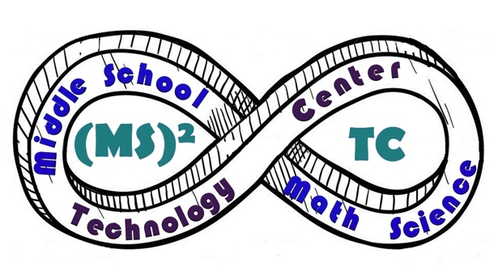 | WCS Middle School Math Science  Technology Center (MS)²TC Accelerated 6th Grade Mathematics  2015 - 2016

Teacher: Ms. Carnes
Room Number: 132
Email: ccarnes@wcskids.net
Website: www.mscarnes.weebly.com

Program Vision: M – Make every day count.
S – Show up, meet challenges, persevere.
2 – To always honor fellowship and community.
T – Team work, cooperation, collaboration.
C – Celebrate uniqueness and build character.

Overview: The (MS)²TC Accelerated 6th Grade Mathematics course curriculum is aligned with the 6th and 7th Grade Common Core State Standards (CCSS). The CCSS provide a consistent, clear understanding of what students are expected to learn and are designed to be robust and relevant to the real world, reflecting the knowledge and skills that students need for success in college and careers. This course focuses on using the eight mathematical practices outlined in the CCSS. Students will utilize a discovery, task-oriented, approach to learning. Topics include: Number Sense, Proportional Reasoning, Expressions and Equations, Algebra, Probability, Statistics, and Geometry.

Expectations: 1) Don’t Be Absent.
2) Be on Time.
3) Come to Class Prepared.
4) Put Forth Maximum Effort.
- When I Am Speaking, You Are Listening.
- No Shyness!
- No Excuses.

Supplies: Please bring the following supplies to class everyday…

- Writing Utensils
- Checking Pens (A color besides black or blue)
- ½” or 1” 3-Ring Binder
- 1-Subject Spiral Notebook
- Agenda
- Free Reading Book
- Basic calculator for at home
Appreciated Donations:

*Box of Tissues
*Glue Sticks
*Hand Sanitizer
*Dry Erase Markers

Grading Policy:
Homework: 25%
Assessments (Quizzes, Tests & Projects): 75%

Homework is usually done in class, but may need to be finished at home. Some work will be independent and some will be group work. The average of all your homework assignments will be 25% of your grade. Because each math lesson builds on the next, all work must be completed on time.

Assessments will be given and consist of quizzes, tests and projects. Assessments will be 75% of the total grade.

Late Work: Missing work will be graded at 0% until received and graded and
will be designated with the code MISSING in Power
School. Late work received after the due date will be given 50%
and designated with the code LATE.

Absent Work: You are responsible for all absent work. Please use this hierarchy when finding absent work…
- Collect absent work from absent box.
- Check with a classmate.
- Confirm assignments with your teacher, if needed.
Absent work will be designated as a 0% with a code of MISSING until the work is turned in and graded.

Re-Take Policy: Any work that earns less than a B- average can be redone for an
averaged grade.

To re-take a test or quiz, students must make corrections on the old assessment in order to take the re-take.
Please complete and return this page of the Accelerated 6th Grade Math class syllabus to Ms. Carnes as acknowledgement of receipt of the document and that you have read and understand its contents. Thank you.
Student Name (print) _________________________________________________________________

Student Section (circle one) 6A 6B 6C 6D 6E 6F

Student Signature _________________________________________________________________

Parent/Guardian Name (print) ________________________________________________________

Parent/Guardian Signature ___________________________________________________________

Parent Phone Number ________________________________________________________________

Parent E-mail Address ________________________________________________________________

Additional Comments:

___________________________________________________________________________________

___________________________________________________________________________________

___________________________________________________________________________________

___________________________________________________________________________________

___________________________________________________________________________________

